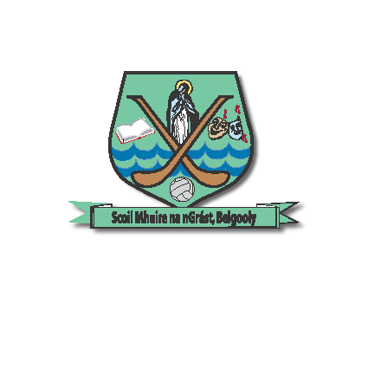Scoil Mhuire na nGrást,

Béal Guala, Fón : 021 4770712

Co. Chorcaí.

Belgooly Central School email : belgoolyns@gmail.com
Belgooly, Co. Cork.
Roll No: 19672H

Dear Parent/Guardian
In relation to the containment of COVID-19, all schools will close from today, Thursday 12th March at 6pm until Sunday, 29th March. Please note that all after-school activities are cancelled for this duration.
Over the coming days, class teachers plan to email suggested pupil work to parents. Pupils will have relevant books in their bags this evening. Your child may have an opportunity to attempt some or all of the activities outlined during the course of next week.
In light of indoor gathering restrictions, we await advice from the Diocese in relation to the sixth class confirmation ceremony which is planned for Thursday, 19th March. A further text will follow in due course.
It is expected that schools and families will be updated by the relevant authorities, as the need arises and the current situation evolves.
Kind regards
Diarmuid Hennessy
School Principal

